**Sjogren's Information App**

*Everything you need to know about Sjogren’s*

**SoftWares Inc.**

**Allen Treichel, Chilembwe Asante, Momin Farooq**

**Template downloaded from****<https://payhip.com/b/POT9>**

**Modified by M. McGill**

## ***Table of Contents***

Index

1 App Working Title

2 Design History

2.1 Summary

3 App Overview

3.1 App Concept

3.2 Feature Set

3.3 Genre

3.4 Target Audience

3.5 App Flow Summary

3.6 Look and Feel

3.7 Project Scope

3.7.1 Estimated Project Life-Cycle

3.7.2 Number of Screens

3.7.3 Monetization Method

3.7.4 Etc.

4 App Play and Mechanics

4.1 App Play

4.1.1 App Progression

4.1.2 Reward Structure

4.1.3 Objectives

4.1.4 Play Flow (First Time Users)

4.1.5 Play Flow (Returning Users)

4.2 Mechanics

4.2.1 Actions

4.2.1.1 Switches and Buttons

4.2.1.2 Purchasing

4.2.1.3 Interacting

4.2.1.4 Posting

4.2.1.5 Logging On / Logging Off

4.2.2 Economy

4.3 Screen Flow

4.3.1 Screen Flow Chart

4.3.2 Screen Descriptions

4.3.2.1 Main Menu Screen

4.3.2.2 Options Screen

4.3.2.3 Etc.

4.3.3 App Options

4.3.4 Returning Users and Saving

4.3.5 Cheats and Easter Eggs

5 Design and App World Building

5.1 Design

5.1.1 Design Storyboard

5.1.2 Key Elements

5.1.3 App Progression

5.1.4 License Considerations

5.2 App World

5.2.1 General Look and Feel of App World

5.2.2 Current App

5.2.2.1 General Descriptions

5.2.2.2 Physical Characteristics

5.2.2.3 Screens that use the App

5.2.2.4 Connections to Expansions

6 Interface

6.1 Visual System

6.1.1 Display

6.1.2 Menus

6.1.3 Camera

6.1.4 Etc.

6.2 Control System

6.3 Audio

6.3.1 Music

6.3.2 Sound Effects

6.4 Help System

7 Artificial Intelligence

7.1 Support AI

7.1.1 Error Detection

7.1.2 Path-finding

7.1.3 In-App Interaction (Etc.)

8 Technical

8.1 Target Hardware

8.2 Development hardware and software

8.3 App Engine | API's

8.4 Network

8.5 Scripting Language

8.6 Etc.

9 App Art

9.1 Concept Art

9.2 Style Guides

9.3 Screens

9.4 Icons

9.5 Items

9.6 Miscellaneous

10 Secondary Software

10.1 Editor

10.2 Installer

10.3 Update Software

11 Management

11.1 Detailed Schedule

11.2 Budget

11.3 Risk Analysis

11.4 Localization Plan

11.5 Test Plan

12 Appendices

12.1 Asset List

12.1.1 Art

12.1.1.1 Texture List

12.1.1.2 Icon List

12.1.1.3 Effects List

12.1.1.4 Interface Art List

12.1.1.5 Etc.

12.1.2 Sound

12.1.2.1 Interface Sounds

12.1.2.2 Error Sounds

12.1.2.3 Currency Sounds

12.1.2.4 Pop-ups

12.1.2.5 Etc.

12.1.3 Music

12.1.3.1 Ambient

12.1.3.2 “Action”

12.1.3.3 Opening

12.1.3.4 Etc.

12.1.4 Miscellaneous

*App Overview*

## **App Concept**

This app provides information about Sjogren’s Syndrome and allows users to donate to the Sjogren’s Foundation. The app will have notes for doctors, patients and family members.

Sjögren’s (“SHOW-grins”) is a systemic autoimmune disease that affects the entire body. Along with symptoms of extensive dryness, other serious complications include profound fatigue, chronic pain, major organ involvement, neuropathies and lymphomas.

## **Feature Set**

-“Menu” button that lists all buttons and links on apps.

-“What is it?” button that explains what Sjogren’s Syndrome is.

-“Risk Factors” button.

-“Symptoms” button.

-“Causes” button that explains what causes Sjogren’s Syndrome.

-“Donate” button allows users to donate to a Sjogren’s Syndrome foundation.

-“Social Media” button links users to a few social media outlets dedicated to Sjogren’s.

-“YouTube” youtube talk shows by the SSF will automatically upload into the app

-“For Doctors” button links fact sheets and resources for medical professionals. Documents provided the SSF

-“Newsletter” functions as a part of the home screen, widget (auto-update or link to subscribe?)

-“SSF Store” button links user to books and other merchandise the foundation sells

-“Self-Help Booklet” links user to the handbook on the SSF website detailing different ways to survive

-”Share” capabilities

-”Coping with Sjogren's” button to see how to cope with the syndrome

## **Genre**

Educational

## **Target Audience**

-People who are suffering from the disease.

-Family and friends of patients.

-Doctors, medical professionals, benefactors and donors.

-Anyone researching the disease.

## **App Flow Summary**

The user can tap on the home screen menu buttons to navigate to that part of the app. The user may be able to swipe between windows if their device allows. The flow should be somewhat static, we believe that this will provide accessibility for older users.

## **Look and Feel**

The app looks like a regular educational app. Kind of bland, easy to read and navigate for older audiences. The overall theme will be water and moisture related. Maybe water droplets in the background or as windows in the home menu screen. The color scheme will revolve around blue and white mostly, maybe will add a few complementary colors.

## **User Experience**

The user should become briefly immersed in the Sjogren’s Foundation and their mission.

**Project Scope**

There will be no monetization of the App.

General Timeline

Sprint 1: Research & Requirements - 1 week

Sprint 2: Design - 2 weeks

Sprint 3: Prototype I - 2 weeks

Sprint 4: Testing - 1 week

Sprint 5: Prototype II - 1 week

**Estimated Project Life-Cycle**

The project will be completed in 5 sprints. Approx. 4 weeks until completion.

**Number of Screens**

5 or 6 screens in total.

**Monetization Method**

N/A

**Etc.**

*App Requirements, Play, and Mechanics*

## **App Requirements**

Here, list out all of the requirements you created in the Requirements Analysis document. Group these by functionality, and also separate them for the features you intent to target in your app as well as “stretch goals”—the functionality that you would like to add if time permits.

**Functional Requirements List**

-“Menu” drop down menu that lists the different windows of the app. Easy navigation method. Visible in the top left of the screen.

Menu Options List

-“Risk Factors” button.

-“Symptoms” button.

-“Causes” button that explains what causes Sjogren’s Syndrome.

-“Donate” button allows users to donate to a Sjogren’s Syndrome foundation. -“Self-Help/Coping” links user to the handbook on the SSF website detailing different ways to survive

-“For Doctors” button links fact sheets and resources for medical professionals. Documents provided the SSF

-“What is it?” button that drops down a floating window. Provides a concise explanation of what Sjogren’s Syndrome is.

-“Social Media” button links users to all social media outlets dedicated to Sjogren’s Foundation.

-“YouTube” youtube talk shows by the SSF will automatically upload into the app

-“Newsletter” functions as a part of the home screen, widget (auto-update scroller or link to subscribe?)

-“SSF Store” button links user to books and other merchandise the foundation sells

-”Share” capabilities. iOS and Android phones have different methods of sharing capabilities. But the phone software should have a menu dedicated to sharing. This button opens that.

## **App Play**

**App Progression**

Users will progress through the different screens of the app by clicking on the buttons on the home screen of the app, and through the links in the drop-down menu.

**Reward Structure**

Information about Sjogren’s and how to cope with it if you have it.

**Objectives**

Educating the public on Sjogren’s.

**Play Flow (First Time User)**

App will open up directly to the home screen and wait for the user to select a link or change pages.

**Play Flow (Returning User)**

The app will function the same as during the first time use. There is no need to log in, or save any user data.

## **Mechanics**

**Actions**

Learning.

**Switches and Buttons**

Users will traverse different pages of the app via buttons and drop-down menus.

**Purchasing**

There will be links to SSF’s page to allow the user to donate or purchase items in their store, but there will be no in-app purchases to be made.

**Interacting**

Users will be able to interact with our app through pressing buttons and scrolling.

**Logging On / Logging Off**

There will be no need for users to log on or log off.

**Economy**

N/A

## **Screen Flow**

**Screen Flow Chart**

The main menu of the app will have links to multiple other pages. The other pages will contain information about Sjogren’s. The most important information will be accessible from buttons on the home page, and the rest will be accessible through the buttons on the drop-down menu.

**Screen Descriptions**

Each screen will contain different information about Sjogren’s, and the homepage will contain links to all these pages.

**Main Menu Screen**

The main menu screen will be the first thing to come up when you open the app, and it will act as a path to all the other pages. It will also contain brief information about SSF and a video/link to a video with some quick information about what Sjogren’s is.

**Options Screen**

N/A

**Etc.**

## **App Options**

Language options.

Spanish, French etc.

## **Returning Users and Saving**

N/A (No user input)

**Cheats and Easter Eggs**

N/A

*Design and App World Building*

## **Design**

Color Scheme:

Header and Footer: #6495ed Color Hex Cornflower Blue

# Background: #ffdab9 Color Hex Peach Puff

Others: #2c599f Color Hex Steel Blue

# #9ab1d2 Color Hex Light Steel Blue

# #c8dbee Color Hex Light Blue

Text & Fonts:

**Design Storyboard**

**Key Elements**

-Embedded youtube video on homepage

-Pop-up/drop-down menu on home screen

-Links to SSF website

-SSF logo



-Scrolling Newsletter

**App Progression**

Each screen should have the same format. There should be no progression.

**License Considerations**

All logos and information will be provided by SSF with their permission. If any outside information or resources are used we will list them here:

**App World**

This a very real-world app. There should be no fictional undertones connected with the final product. The app has a very serious function that will be designed well-enough to look friendly for everyone.

**General Look and Feel of App World**

The app should feel informative as soon as you open it up. The information should not just be thrown in the users face when they open the app, the app should be inviting at first. This will allow for first time users to become comfortable with the app and use it more often. If the app looks too fictional or too friendly it will take away from its original purpose which is to inform.

**Current App**

N/A

**General Descriptions**

N/A

**Physical Characteristics**

N/A

**Screens that use the App**

N/A

**Connections to Expansions**

N/A

*Interface*

## **Visual System**

**Display**

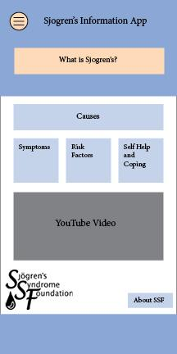

The home page of the app will feature a drop down menu button with 5 buttons, a “What is Sjogren’s” button, a “Causes” button, a “Risk Factors” button, a “Symptoms” button, a “Self Help and Coping” button, the SSF logo, an informational video about Sjogren’s, and an “About SSF” button.

-In the “Menu” button (Top left corner):

* “For Doctors”: Link to SSF’s page with information for doctors.
* “Subscribe to Newsletters”: Link to SSF’s page to subscribe to their newsletters.
* “Social Media”: Allows user to share to Facebook, Twitter, etc.
* “SSF Store”: Link to SSF’s online store.

-“What is Sjogren’s”: Either a drop down panel or a link to another page on the app with information about what Sjogren’s is.

-”Causes”: Links to another page on the app with information about causes.

-”Risk Factors”: Links to another page on the app with information about risk factors.

-”Symptoms”: Links to another page on the app with information about symptoms of Sjogren’s.

-”Self Help and Coping”: Links to another page on the app with information about coping with Sjogren’s.

-”About SSF”: Links to another page on the app with some brief information about SSF.

**Menus**

The home page will feature a drop down menu button with links to other pages and the SSF website.

**Camera**

N/A

**Etc.**

**Control System**

The user will control the app by clicking on buttons and links and scrolling down through pages.

**Audio**

The only audio for the app will be featured in the youtube video on the home page.

**Music**

N/A

**Sound Effects**

N/A

**Help System**

There will be a help button in the options menu that will tell users what what they need to know about using the app.

*Artificial Intelligence*

**Support AI**

N/A

**Error Detection**

N/A

**Path-finding**

N/A

**In-App Interaction (Etc.)**

N/A

*Technical*

## **Target Hardware**

IOS devices, Android Devices

**Development hardware and software**

Hardware:

* Laptops
* Cellphones to check the app

Software:

* PhoneGap
* ANY coder

**App Engine | API's**

**Network**

Internet will be required

**Scripting Language**

-Javascript

-Html

-CSS

*App Art*

## **Concept Art**

Most of the art would be based on the description of clients theme demands, which are basically related to the disease Sjogren. The Theme would be blue, white, orange.

**Style Guides**

N/A

**Screens**



Home Screen, this will be the first screen shown when the user opens the app.

**Icons**

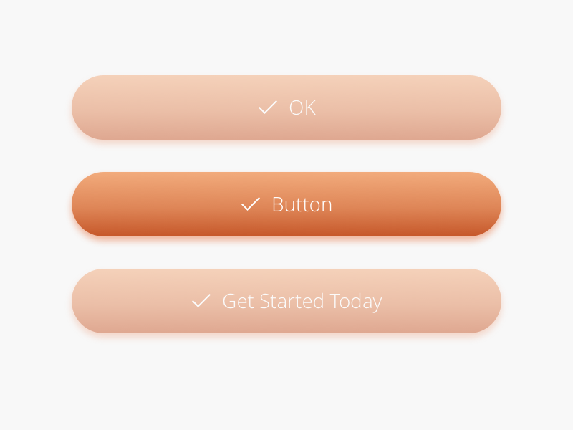

**Items**

N/A

**Miscellaneous**

N/A

*Secondary Software*

## **Editor**

The app will be edited through PhoneGap

**Installer**

App will be available for installation via the App Store/ Google Play Store and can be uninstalled through the user’s phone’s settings

**Update Software**

The app will be updated through PhoneGap

*Management*

## **Detailed Schedule**

Can refer to Trello or Moodle for a more detailed schedule.

Turn in Design Draft - Jan. 23rd

Turn in Final Design Doc - Jan 29th

**Budget**

Hopefully free.

**Risk Analysis**

If the app becomes much harder than we expect (very doubtful). I think we should cut down the app in certain areas, which may be hard because the app is already basic.

Coding the project may prove difficult as our team is inexperienced in using HTML and PhoneGap.

**Localization Plan**

There will be a translate button that will allow the user to change the language of the app.

**Test Plan**

We will let release a beta to a select group of testers upon completion.

*Appendices*

## **Asset List**

N/A

**Art**

N/A

**Texture List**

None

**Icon List**

None

**Effects List**

None

**Interface Art List**

N/A

**Etc.**

N/A

**Sound**

**Interface Sounds**

N/A

**Error Sounds**

N/A

**Currency Sounds**

N/A

**Pop-ups**

N/A

**Etc.**

N/A

**Music**

**Ambient**

None

**“Action”**

None

**Opening**

None

**Etc.**

N/A

**Miscellaneous**